

Mechanics of Machinery Final Report

Hadi Elnemr

46-6804

T-29

**Mechanism under study:**

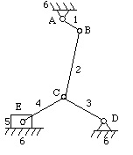

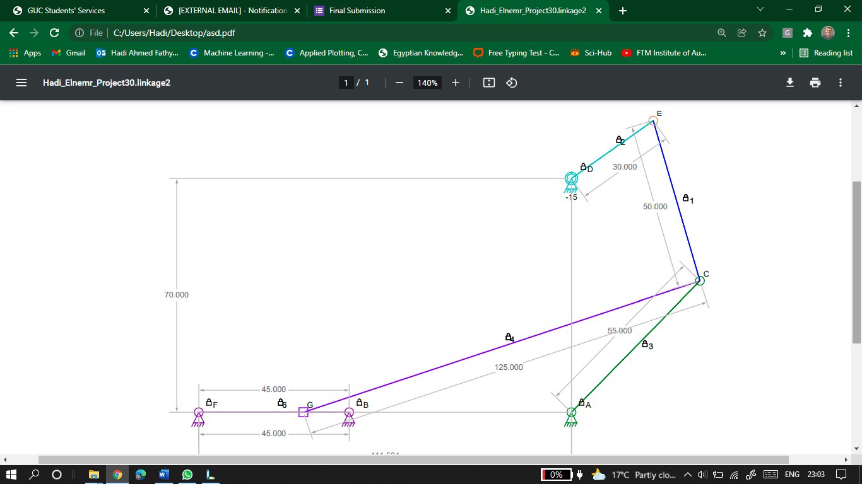

**Mechanism in Linkage:**

**SolidWorks 2D Graphical Analysis:**

* **Position Analysis**

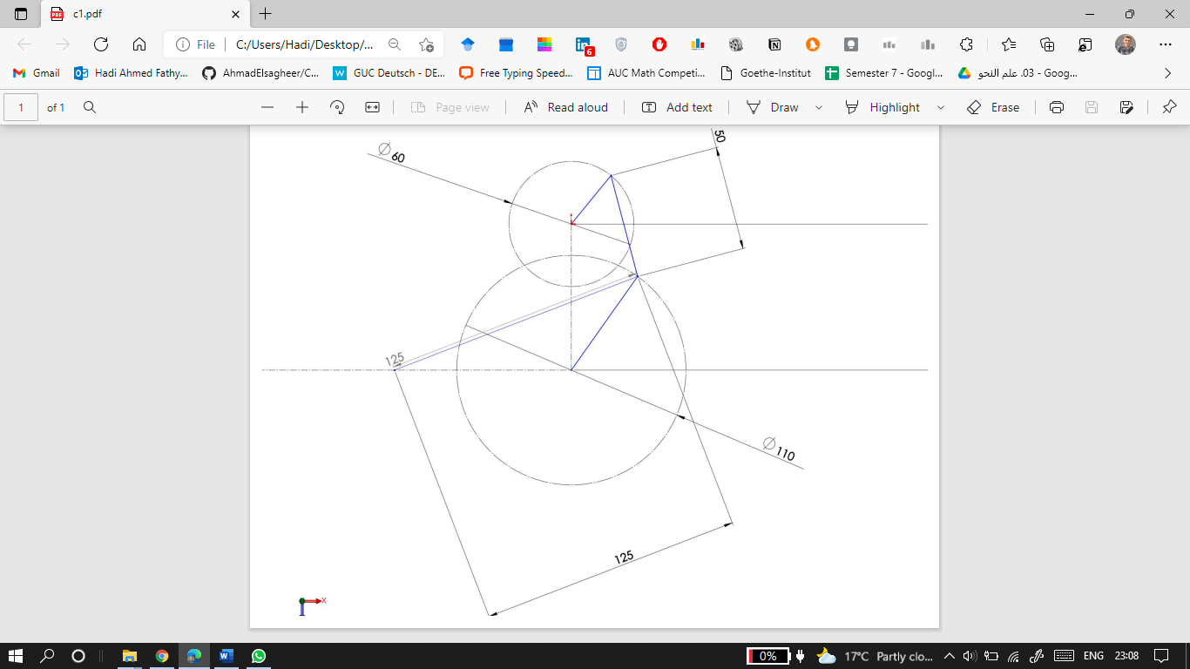

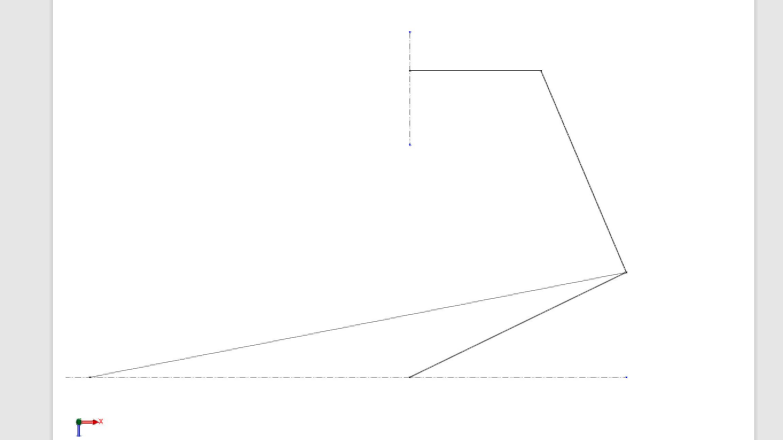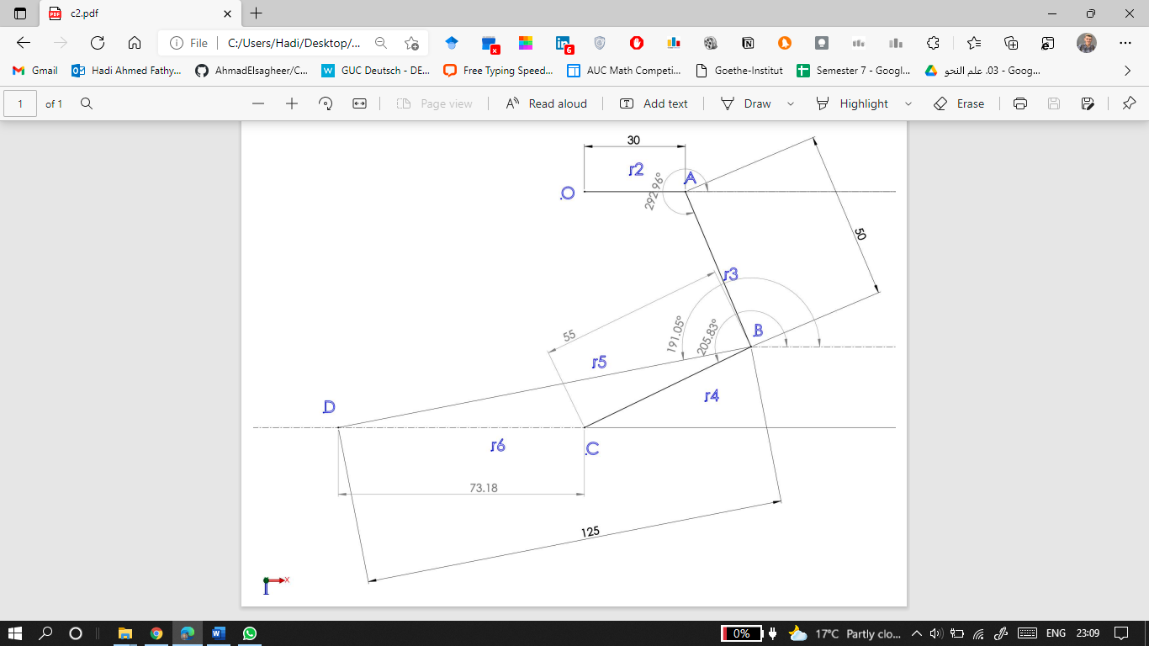At

* **Velocity Analysis**

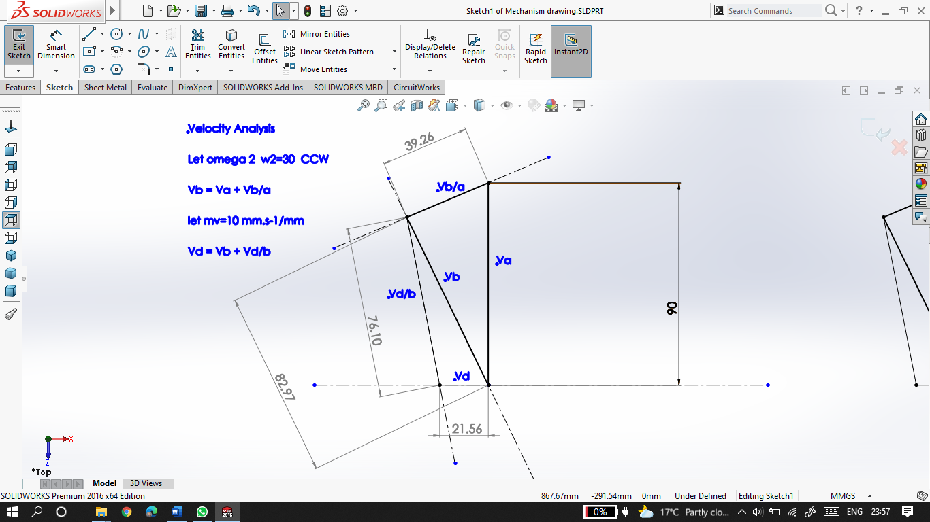

* **Acceleration Analysis:**

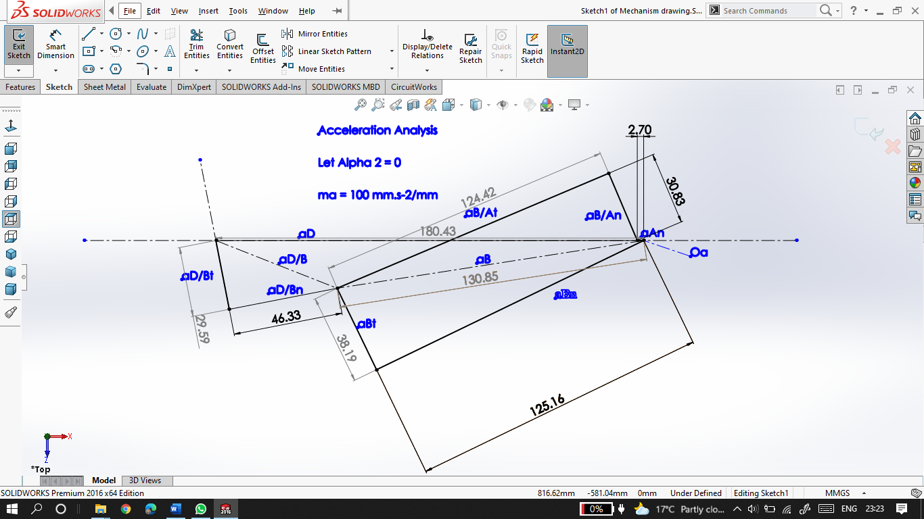

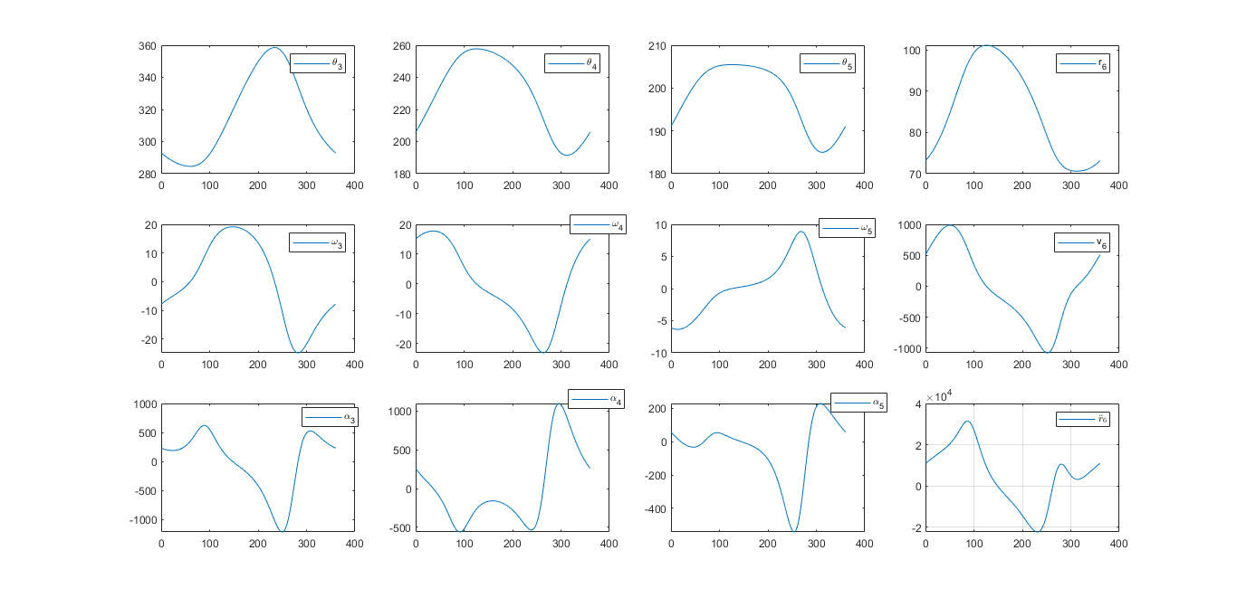**MATLAB Simulations:**

**Comparing Results**

|  |  |  |
| --- | --- | --- |
| for θ­­2 = 0,  CCW, | MATLAB | SolidWorks |
|  | 292.9618 | 292.96 |
|  | 205.8278 | 205.83 |
|  | 191.0517 | 191.05 |
|  | 83.1759 mm | 73.18 |
|  | -7.8519 rad/s | -7.852 CW |
|  | 15.0859 rad/s | 15.085 CCW |
|  | -6.0876 rad/s | 6.088 CCW |
|  | 507.3559 mm/s | 215.6 🡨 |
|  | 232.9229 rad/s2 | 248.84 CW |
|  | 259.2629 rad/s2 | 237.909 CCW |
|  | 56.7787 rad/s2 | 236.72 CW |
|  | 10941 mm/s2 | 18043 🡨 |

**MATLAB Codes**

**Main Script:**

close

clc %this line just clears your command window

clear

i=1;

options = optimset('display', 'off');

r=[70 30 50 55 125];

w2=30; %rad/sec

th1=270*pi/180;

prev_w3 = 1;

prev_w4 = 1;

for theta=0:1:360

the(i)=theta*pi/180; % saves each value of the input theta in an array

% Where theta is theta 2

theta34(:,i)=fsolve(@position_1,[5.23 3.9],options,the(i),r);

thetas = [th1 the(i) theta34(:,i)'];

if theta34(1,i)<0

theta34(1,i)=theta34(1,i)+2*pi;

end

if theta34(2,i)<0

theta34(2,i)=theta34(2,i)+2*pi;

end

if theta34(1,i)>2*pi

theta34(1,i)=theta34(1,i)-2*pi;

end

if theta34(2,i)>2*pi

theta34(2,i)=theta34(2,i)-2*pi;

end

theta4=theta34(2,i);

theta5r6(:,i)=fsolve(@position_2,[3.9 70],options,theta4,r);

if theta5r6(1,i) < 0

theta5r6(1,i)=theta5r6(1,i)+2*pi;

end

if theta5r6(1,i) > 2*pi

theta5r6(1,i)=theta5r6(1,i)-2*pi;

end

thetas(5)=theta5r6(1,i);

omega34(:,i)=fsolve(@velocity_1,[prev_w3 prev_w4], options, thetas, r, w2);

omegas = [0 w2 omega34(:,i)'];

prev_w3 = omega34(1,i);

prev_w4 = omega34(2,i);

w4=omegas(4);

omega5r6d(:,i)=fsolve(@velocity_2,[50 1], options, thetas, r, w4);

omegas(5)=omega5r6d(1,i);

alpha2=0;

alpha34(:,i)=fsolve(@acceleration_1,[100 1], options, thetas, r, omegas, alpha2);

alpha4=alpha34(1,i);

alpha5r6dd(:,i)=fsolve(@acceleration_2,[100 1], options, thetas, r, omegas, alpha4);

i=i+1;

end

theta34=theta34*180/pi;

theta5r6(1,:)=theta5r6(1,:)*180/pi;

the = the*180/pi;

m=3;

n=4;

subplot(m,n,1)

plot(the(1,:),theta34(1,:)); legend('\theta_3')

subplot(m,n,2)

plot(the(1,:),theta34(2,:)); legend('\theta_4')

subplot(m,n,3)

plot(the(1,:),theta5r6(1,:)); legend('\theta_5')

subplot(m,n,4)

plot(the(1,:),theta5r6(2,:)); legend('r_6')

subplot(m,n,5)

plot(the(1,:),omega34(1,:)); legend('\omega_3')

subplot(m,n,6)

plot(the(1,:),omega34(1,:)); legend('\omega_4')

subplot(m,n,7)

plot(the(1,:),omega5r6d(1,:)); legend('\omega_5')

subplot(m,n,8)

plot(the(1,:),omega5r6d(2,:)); legend('v_6')

subplot(m,n,9)

plot(the(1,:),alpha34(1,:)); legend('\alpha_3')

subplot(m,n,10)

plot(the(1,:),alpha34(2,:)); legend('\alpha_4')

subplot(m,n,11)

plot(the(1,:),alpha5r6dd(1,:)); legend('\alpha_5')

subplot(m,n,12)

plot(the(1,:),alpha5r6dd(2,:));

hl = legend('$\ddot{r}_6$')

set(hl, 'Interpreter', 'latex');

grid;

**Position1:**

function w=position_1(output, th2, r)

r1=r(1);

r2=r(2);

r3=r(3);

r4=r(4);

th1=270*pi/180;

th3 = output(1);

th4 = output(2);

w=[-r1 * cos(th1) + r2 * cos(th2) + r3 * cos(th3) + r4 * cos(th4);

-r1 * sin(th1) + r2 * sin(th2) + r3 * sin(th3) + r4 * sin(th4)];

end

**-------------------------------------------------------**

**Position2:**

function w=position_2(output, th4, r)

r4=r(4);

r5=r(5);

th6=pi;

th5 = output(1);

r6 = output(2);

w=[ - ( r5 * cos(th5) ) + r4 * cos(th4) + r6 * cos(th6);

- ( r5 * sin(th5) ) + r4 * sin(th4) + r6 * sin(th6);

];

end

**-------------------------------------------------------**

**Velocity1:**

function w=velocity_1(output, theta, r, w2)

r1=r(1);

r2=r(2);

r3=r(3);

r4=r(4);

th2=theta(2);

th3=theta(3);

th4=theta(4);

w3=output(1);

w4=output(2);

w = [ w2 * r2 * cos(th2) + w3 * r3 * cos(th3) + w4 * r4 * cos(th4) ;

w2 * r2 * sin(th2) + w3 * r3 * sin(th3) + w4 * r4 * sin(th4) ;

];

end

**Velocity2:**

function w=velocity_2(output, theta, r, w4)

r4=r(4);

r5=r(5);

th6=pi;

th4=theta(4);

th5=theta(5);

w5=output(1);

r6_dot=output(2);

w = [ w5 * r5 * sin(th5) + ...

-w4 * r4 * sin(th4) + ...

r6_dot * cos(th6) ;

w5 * r5 * cos(th5) + ...

w4 * r4 * cos(th4) + ...

r6_dot * sin(th6) ;

];

end

**-------------------------------------------------------**

**Acceleration1:**

function w=acceleration_1(output, theta, r, w,a2)

r1=r(1);

r2=r(2);

r3=r(3);

r4=r(4);

%th1=theta(1);

th2=theta(2);

th3=theta(3);

th4=theta(4);

%w1=w(1);

w2=w(2);

w3=w(3);

w4=w(4);

a3=output(1);

a4=output(2);

w=[ -w2^2 * r2 * cos(th2) - a2 * r2 * sin(th2) + ...

-w3^2 * r3 * cos(th3) - a3 * r3 * sin(th3) + ...

-w4^2 * r4 * cos(th4) - a4 * r4 * sin(th4) ;

-w2^2 * r2 * sin(th2) + a2 * r2 * cos(th2) + ...

-w3^2 * r3 * sin(th3) + a3 * r3 * cos(th3) + ...

-w4^2 * r4 * sin(th4) + a4 * r4 * cos(th4)

];

end

**Acceleration2:**

function w=acceleration_2(output, theta, r, w,a4)

r4=r(4);

r5=r(5);

th4=theta(4);

th5=theta(5);

th6=pi;

w4=w(4);

w5=w(5);

a4=a4;

a5=output(1);

r6_ddot=output(2);

w=[ -( -w5^2 * r5 * cos(th5) - a5 * r5 * sin(th5))+ ...

-w4^2 * r4 * cos(th4) - a4 * r4 * sin(th4) + ...

+r6_ddot * cos(th6) ;

-( -w5^2 * r5 * sin(th5) + a5 * r5 * cos(th5))+ ...

-w4^2 * r4 * sin(th4) + a4 * r4 * cos(th4) + ...

+r6_ddot * sin(th6) ;

];

end